# 6115-mahendra institute of engineering and technology

# Smart parking systEM

**TEAM ID:­572**

**TEAM: PROJ_223289_TEAM_1**

**PHASE_3**

|  |
| --- |
| Team members:  1. DEVAPRAKASH R 2. LOGESHWARAN G 3. MANIKANDAN K.A 4. ARUNKUMAR P 5. KAMALNATH A 6. GUNASEKARAN M   **FACULTY MENTOR NAME:**  SANTHANARAJ M |

**INITIALIATION:**

* Functional Requirement Functional Requirement defines a function of a software system and how the system must behave when presented with specific inputs/or conditions. These may include calculations, data manipulation and processing and other specific functionality. In these systems following are the functional requirements

• The application should not display in-appropriate message for valid conditions. • The application must not stop working when kept running for even a long time

• The application should process information for any kind of input case.

• The application should generate the output for a given input test case .

**Non-Functional Requirement**

* Non-functional requirements are the requirements which are not directly concerned with the specific function delivered by the system. They specify the criteria that can be used to judge the operation of a system rather than specific behaviours. Given below are the

**Non-functional requirements**:

• Product requirements

• Organizational requirements

• Basic operational requirements

**Hardware Specifications**

• ENODE MCU (ESP8266)

• JUMPER WIRES

• INFRARED SENSORS

• 16*2 LED DISPLAY

• DC MOTOR

**Software Specification**

• ARDUINO IDE

**EXECUTION:**

**SYSTEM ANALYSIS AND DESIGN**

**Node Mcu**

* The Node MCU as shown in has assimilated TCP/IP protocol that can give any microcontroller entrance to the Wi-Fi network that supports 2.4 GHz Wi-Fi (802.11 Wi-Fi standards). Node MCU is capable of either connecting to an existing wireless connection or hosting an application over http protocol. Each Node MCU module comes pre-programmed with an AT command set firmware which means one can simply link this up to your Raspberry Pi device and get about like Wi-Fi shield. The reason why we use node mcu is that it is more cost-efficient with respect to Arduino uno , in Arduino we have to use ethernet shield which provides us secure ethernet connectivity whereas all these features are provided by node mcu and it also comes with a updated feature of wi-fi , where you can power or connect your system by WiFi .

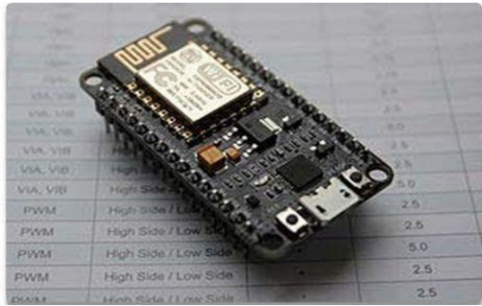

**Node MCU Module**

**16*2 LCD Display**

* An LCD is an electronic display module which uses liquid crystal to produce a visible image. The 16×2 LCD display is a very basic module commonly used in DIY’s and circuits. The 16×2 translates o a display 16 characters per line in 2 such lines. In this LCD each character is displayed in a 5×7 pixel matrix. The 16*2 display is used to display the number of vacant and spilled spot . It also gets updated on the display LCD when a vehicle parks or unparks the vehicle .

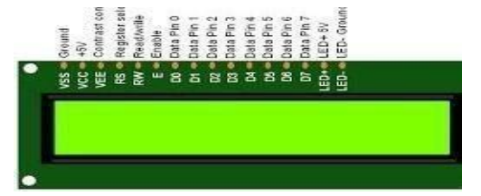

IR sensor An infrared (IR) sensor is an electronic device that measures and detects infrared radiation in its surrounding environment. Infrared radiation was accidentally discovered by an astronomer named William Herchel in 1800. While measuring the temperature of each color of light (separated by a prism), he noticed that the temperature just beyond the red light was highest. IR is invisible to the human eye, as its wavelength is longer than that of visible light (though it is still on the same electromagnetic spectrum). Anything that emits heat (everything that has a temperature above around five degrees Kelvin) gives off infrared radiation. We are using three IR detect sensor in our project , one IR detect sensor is used to sense the vehicle near the parking sensor and other two IR detect sensor is used to send data to the node mcu which is the brain of our system whether a vehicle is parked in that slot or is unparked .

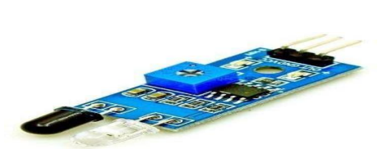

* System Architecture The below diagram shows the pin diagram of our model. It consists of one node mcu , one dc motor , one 16*2 LCD display and three IR sensors .The node mcu is the brain of our system which powers all the other devices .The 16*2 LCD display is powered by node mcu by connecting jumper wires from the display to node mcu . The DC motor is also powered by node mcu with connecting its pins to node mcu. The IR sensor consists of three pins, where two pins refer to the power supply and ground and the other pins refer to the pin which is going to be connected in the Node mcu. On successfully connecting all the components in the given figure now we have to connect the blynk app. While using the blynk app we have to specify the widgets used in our android app and the pin number to which they are connected to node mcu in the actual model so that the mobile app will react exactly to the inputs provided in the model .

**IMPLEMENTION**

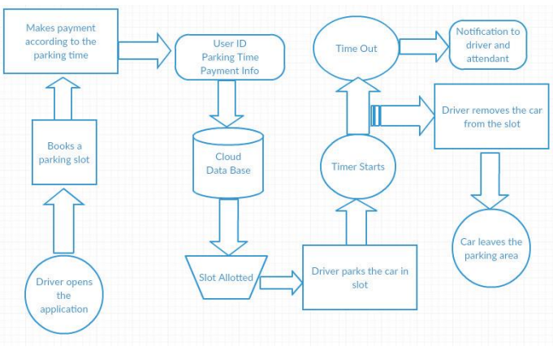

* Below are the steps that a driver needs to follow in order to park its car using our parking system.

Step 1: Install the smart parking application on your mobile device.

Step 2: On the 16*2 display the number of vacant and filled spots are displayed so that the user can see the status of parking zone.

Step 3: Once the user logs into the app he would see the parking architecture with the cars filled at which position and positions which are empty .

Step 4: When the user is near to the parking IR detect sensor , he would receive a notification on his app on which slot he can park his vehicle if there is a empty slot.

Step 5: If there is no empty slot the user will be displayed with an appropriate message on the mobile application .

Step 6: On availability of parking area and user parking into the respective slot he/she would receive a message which states the start time of the parking and the slot in which he/she has parked.

Step 7: On successfully un-parking your vehicle from the parking slot the user will receive a message which states the start time and end time of his parking time and an amount which he needs to pay for the parking duration.

**Design of the System**

The picture shows the miniature model of the Automated Car Parking Lot.

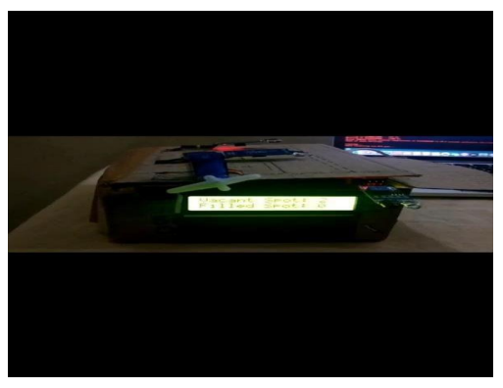

**Experimental Setup**

* This model has the capacity of containing two cars. There are two sensors at the entrance to detect the presence of a car before going inside or outside of the parking lot. The other two sensors are plotted inside the parking lot to detect the car individually for each parking slot. A DC Servo motor has been used at the entrance to open and close the gate according to the signals sent by the sensors through Arduino.

* The projection on the screen corresponds to the system model parking slots. This is a real time display regarding the status of the parking lot. As this is a web-based representation, anyone will be able to get the status of the parking lot by visiting the website on the URL through their cell phones, laptops, desktops and other internet supporting devices. The model of the parking lot has two parking slots. Thus, we can park a maximum number of two cars through the system.

* We have used two IR sensors which when vehicle parked will show appropriate message to the user and when all the parking slots the dc motor would not open gate for the vehicle to be parked. Displaying of appropriate message for any action which takes place in the parking zone is done effectively and efficiently

**Network Time protocol :-**

* The Network Time Protocol is a networking protocol for clock synchronization between computer systems over packet-switched, variable-latency data networks. We have used NTP for fetching time from the NTP server so that we can show the start time and end time for the user when he parks or unparks his vehicle making information real-time.

**Blynk app:-**

* Blynk app is a hardware-agnostic IoT platform with white label mobile apps, private cloud ,device management, data analytics and machine learning .On using the blynk app we tried to pop notification to every possible event that is occurring in the parking zone .
* Used a serial algorithm to display the slot number to the user who is going to park his vehicle .For example we display the empty slot number in a serial manner which gets filled , if the slot 1 is filled and when an another vehicle turns up we display slot 2 and further like these for all other vehicles , and if any vehicle leaves the slot number then we display the earlies slot number , not making the user to travel long if an initial spot is vacant .

**Controling:**

* Embedded systems are growing rapidly with the ability to provide high-speed information exchange between devices in communication systems. It has been one of the most common subjects of study since the 1960s. In the past ten years, the world has witnessed a technological revolution by access to Embedded systems and the Internet of Things (IoT) in many fields. This has reflected great development in our daily life qualities, services, and gives high efficiency.
* Modern embedded systems are often based on microcontrollers. That is the reason why the embedded system is dedicated to specific tasks. Besides, design engineers can optimize embedded systems to reduce the size and cost of the product and increase the reliability and performance.
* Recently, a lot of studies and researches on smart cities have been monitored with the expansion of the concept of the IoT, the widespread of what is known as the cloud, how to benefit from it in storing and sharing the data accurately and high quality, and creating the databases. Which made life easier and more civilized.
* The IoT applications have a great impact on communication system everywhere. it can remotely operate and analyze data, as well as communicate with many around sensors devices and managed complex systems, via controlling them through mobile systems applications such as IOS, and Android.
* One of the most important examples of the Internet of Things applications, smart parking, allow drivers to park their vehicle easily and quickly. It reduces traffic congestion and thus reduces environmental pollution resulting from car exhaust.

* The smart parking based on authorized access is proposed in this work, which allows entering parking via ID card working with the Radio Frequency Identification (RFID) device placed at the gate of parking.
* In this work, all sensors are connected to the microcontroller using Arduino Mega 2560 to contains enough input/output pins. To send data, the number and location of empty places to the cloud, a Message Queuing Telemetry Transport protocol (MQTT) through the WiFi of the Nodemcu esp8266, have been used.
* The mobile application has been implemented on the Android system to receive the data from the JavaScript Object Notation database (JSON), which stored in the cloud, which display all information on a screen to allow users park their vehicle easier and faster. This paper is organized as follows, introduction in section one, related work in section two, description of the equipment that was used in this work in section three, algorithm and operating system in section four, conclusion, future work, and finally acknowledgments.

**Description of equipment:**

In this section the equipment that is used in this work includes are considered:

* Arduino Mega 2560.
* It's an open-source physical measure description based on a direct microcontroller board that includes an ATmega328 microcontroller and an improved environment for writing software for the board. Arduino is used to connecting and communicating between various devices.
* Arduino Mega 2560 is one of the most famous boards for microcontrollers ATmega 2560, with many input/outputs pins (54 digital pins and 16 analog pins, using 16 MHz with local crystal) to implement large projects that contain sensors, power supply, switches as input while outputs that control the various devices such as lighting, sound …etc. as shown in Figure1. Also any projects that rely on the Arduino can be accomplished by the computer through different programs.
* Nodemcu esp8266
* There are a lot of devices that are used with the embedded systems and the Internet of Things (IoT) with various features, NodeMCU is a low-cost open-source IoT platform of the microcontrollers with builtin a Wi-Fi 802.11 support b/g/n.
* As shown in Figure 1. This module comes with a built-in USB connector and a rich assortment of pin-outs. With a micro USB cable, it can use to publish or respond in the database, which uses the MQTT protocol, MQTT is more accurate and requires less time to complete the transmission.
* From the above, Nodemcu using in many applications, IoT devices, low power battery-operated applications, network projects. Projects requiring multiple I/O interfaces with Wi-Fi and Bluetooth functionalities.

**CLOSING:**

* IoT has many different applications, but one of the most exciting is its use in smart parking. IoT-based parking systems are able to better track the availability of parking spots on a given lot, making it easier to find an available parking spot.
* It is important to note that not all IoT-based parking systems are the same. For example, some use QR codes to identify available parking spots, while others use sensors to detect when a car leaves a parking spot. The benefits of an IoT-based smart parking system are that it is more creative, efficient, and convenient for both drivers and owners of the parking lot.

**THANKING YOU**